Developing theoretically and empirically sound social procurement programs that do what they claim to do

This is the ninth fact-sheet about recent international peer-reviewed social procurement research led by the University of Technology, Sydney, Australia.

This fact sheet summarises a research project which undertook to produce a theoretically and empirically sound evaluative SROI analysis of a UK construction training program designed to reduce the risk of youth homelessness.

Many social procurement programs are theoretically and empirically flawed and therefore lack reliable evidence to support the social impacts being claimed. Such programs are unlikely to achieve the social impacts they seek to make and may even do more harm than good to the vulnerable communities they are meant to help.

The results of this research are currently subject to international peer-review in the draft manuscript listed in the footnote of this factsheet. Depending on the outcome of this process, the results will be published in late 2022 or possibly 2023. Please feel free to distribute this factsheet to anyone who may be interested.

Professor Martin Loosemore
University of Technology, Sydney
https://profiles.uts.edu.au/Martin.Loosemore

Why the study
- Government social procurement policies are requiring construction supply chains to demonstrate how they will create social value as a condition of securing public sector construction contracts.
- Procuring authorities need to evaluate tender submissions to ensure that the social value benefits claimed by a contractor from its social procurement programs are likely to eventuate.
- Contractors need to rigorously demonstrate that their social procurement initiatives will achieve the social impacts they claim.
- While some governments provide detailed guidance to procuring authorities to assist in the tender assessment process, the problem for both tendering contractors and procuring authorities is that independent empirical research relating to social procurement program design and evaluation is limited.
- The field of social procurement is typified by highly anecdotal and shallow case studies. Publicly available SROI reports and cost/benefit analyses are of variable transparency and quality.
- Despite guidance recommending the development of ‘theories of change’ to underpin program design, many initiatives are not theoretically and empirically sound.
- Many theories of change are underpinned by tenuous assumptions about cause-and-effect. This means there is no sound and consistent basis on which practical initiatives can be built and justified.
- This lack of evidence and theory, coupled with highly variable expertise in social impact measurement, undermines the legitimacy of social procurement as an effective policy intervention.
- It also inhibits innovation and learning between organisations responsible for implementing these policies and enables unscrupulous organisations to over-claim the social impact.
- Poorly designed programs which are not underpinned by a rigorous theoretical and empirical base, are unlikely to achieve their intended outcomes and potentially do more harm than good to the already vulnerable people they are meant to help.

Aim
- The aim of this research was to develop a theoretically informed and methodologically robust evaluative social return on investment (SROI) analysis of a construction training program developed in the UK by a charity called Llamau and The Construction Youth Trust to reduce the risk of youth homelessness.
- Utilising Sen’s Capability Empowerment Approach, the research aimed to advance social procurement research and practice by providing much needed empirical and theoretical evidence of the social impact of the program on the lives of the young people it was designed to help.
- By subjecting the SROI to international peer-review and publishing the results, the research aims to add to the very limited body of independently peer-reviewed evidence of the impact of social procurement programs.
What we did

- We conducted a theoretically informed evaluative SROI of a construction training program developed to reduce the risk of youth homelessness.
- We employed a SROI methodology over traditional CBA because it provided a holistic and bottom-up approach which enabled us to understand more deeply how the program we were studying contributed to the fulfilment of social goals from beneficiary’s perspectives.
- The empowerment of stakeholders is especially important in accommodating varying notions of social value which may be culturally dependent. For example, Indigenous communities can have very different notions of social value to non-Indigenous communities.
- SROI is also a useful communication tool, expressing social value in a language which different cultures can understand. This provides important legitimisation benefits which increases transparency and confidence in claimed impacts.
- The program studied was a UK construction focussed training program called Symud Ymlaen/ Moving Forward (SYMF) which provided tailored and individualised packages of training, support and work experience for young people at risk of homelessness.
- The young people taking part in the program faced many barriers to employment and a high risk of homelessness. Few had worked, many had been excluded from school, some had harmful substance misuse habits, and some were known to youth justice and care system.
- To produce a theoretically sound SROI assessment of SYMF we employed the Capability Empowerment Framework developed by Sen (1985) and Nussbaum (1993, 2000, 2011).
- The advantage of the Capability Empowerment Framework is its premise that people’s risk of homelessness and associated unemployment is determined by structural disadvantage rather than personal failure. By building the capabilities in the framework evidence indicates that these structural disadvantages can be reduced.

The framework is summarised below.

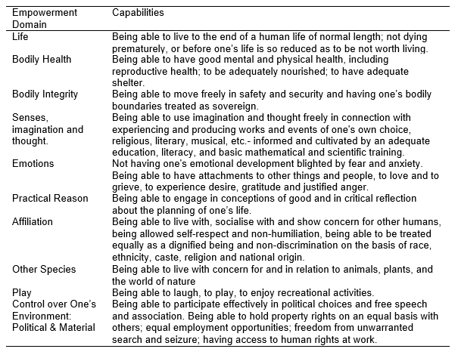

- Data was collected using a mix of qualitative and quantitative methods and primary and secondary data. This included: interviews with young people who went through the program; focus groups with program stakeholders; various documents relating to each young person’s background and progress before, during and after the SYMF program; and publicly available data to create a theory of change and choose appropriate proxies for valuing outcomes.

What we found

- The Capability Empowerment Framework provided a useful theoretical foundation to study the impacts of this program.
- The results show that the SYMF program helped reduce the risk of homelessness by building capacity across many Capability Empowerment Framework domains.
- The life domain was improved by increased housing security from greater income and more positive relationships, as was the affiliation and emotions domains.
- The health and bodily integrity domains were improved by improvements in participant’s mental and physical health and increasing awareness of health and safety issues.
- The senses and imagination and practical reason domains were improved by greater numeracy and literacy and by having the confidence to forward-plan their lives.
- The program not only allowed these social impacts created to be defined and quantified, but also enabled the valuation of the wider economic value that was generated by investing in this program.
What this means

- The insights from this research into the social and economic impacts of this program are potentially valuable to other organisations which are required to address homelessness as part of their social procurement obligations.
- Compared to existing anecdotal case studies, research like this can improve the effectiveness of program design and help organisations to better legitimise and differentiate their programs from competitors in the eyes of clients and potential social impact investors.
- However, the SROI methodology had limitations. For example, despite being transparent and open with our assumptions, we found that social impact was difficult to identify because of the difficulties in establishing direct causal links between the SYMF program analysed and the outcomes valued. Furthermore, there are challenges in selecting appropriate proxies for valuing outcomes.
- Despite these challenges and limitations, research like this is a major improvement on the anecdotal case studies which currently characterise the field of social procurement.
- Research like this is important in ensuring that programs being developed in response to new social procurement requirements in the construction sector can be assessed by construction clients as robust and reliable in achieving the outcomes that they purport to deliver.
- Finally, research like this can help legitimise social procurement as a potentially valuable way to create social value and prevent the over-claiming of social procurement outcomes by unscrupulous or ignorant organisations tendering for government construction and infrastructure contracts.

