Assessing the impact of Indigenous social procurement policies

This is the fourth fact-sheet about recent international peer-reviewed social procurement research led by the University of Technology, Sydney, Australia.

This fact sheet introduces a new framework for evaluating the social impact of Indigenous social procurement policies from the perspectives of Indigenous people.

Full research papers are listed at the bottom of the page and available on request. Please feel free to circulate this fact sheet.

Professor Martin Loosemore
University of Technology, Sydney
https://profiles.uts.edu.au/Martin.Loosemore

Why the study
- Since colonisation the lives of Indigenous Australians have been the subject of often conflicting, constantly changing and poorly evaluated policies and programmes.
- These policies have ‘othered’ Indigenous Australians by treating them differently to most Australians.
- Non-Indigenous people have largely decided what was best for Indigenous people, essentially moving them into a Western civilisation nuclear family model of existence.
- This has meant that to be Indigenous is generally to be in receipt of non-Indigenous ideas, programmes and histories and perceptions of social value.
- Government frameworks such as ‘Closing the Gap’ reinforce this approach by focussing on the deficits of Indigenous people rather than strengths and on overcoming ‘Indigenous disadvantage’. This overlooks the inequity which has resulted from colonisation and locates disadvantage in the failure of Aboriginal people.
- During the period of Closing the Gap’s implementation and failure, the Australian Government designed and introduced the Commonwealth Indigenous Procurement Policy (CIPP) in its attempt to engage business in addressing growing inequity between Indigenous and non-Indigenous people.
- Indigenous procurement policies require companies tendering for government construction contracts to create “social value” for Indigenous people living in the communities in which they build, primarily through the provision of employment and business opportunities.
- This paper argues that these policies are unlikely to have their intended social impact if they are removed from Indigenous Australian cultural values, ontologies, epistemologies and lived experiences.
- It argues that the ways in which these policies are developed and their success communicated often fails to respect these differences.
- It therefore questions whether these policies are having their intended affect and introduces the notion of ‘cultural counterfactuals’ as a way of allowing for Indigenous values in social impact assessments.

What we did
- We undertook a critical literature review of social procurement in relation to Indigenous peoples
to develop a new conceptual framework to stimulate discussion of cultural counterfactuals.
- We employed Indigenous Standpoint Theory, Ngaa-bi-nya, Indigenous Value Theory and Strain Theory as to develop a framework for conceptualising cultural counterfactuals.
- This conceptual framework has formed the basis for ongoing empirical PhD research with Indigenous construction companies and their employees to better understand the impact of Indigenous social procurement policies from the perspectives of the Indigenous people they are meant to help.
- This factsheet is a description of the framework alone.
- The outcomes of the empirical research have not yet been published in peer reviewed journals and will be reported at a later date when they have been peer-reviewed.
What we found
- Evaluations are rarely, if ever, built into the design of Indigenous policies or programmes, and they are too often under-taken as an afterthought, with little consultation and with insufficient time or resources set aside for deep insights.
- Existing frameworks used to evaluate various Indigenous programmes have been criticised for being: too generalised and ignoring Indigenous cultural diversity; conducted by outsiders without adequate consultation and involvement of Indigenous communities; and perceived as coming from outside the community’s interest and control.
- Claims about the benefits of Indigenous social procurement policies are often undermined by a lack of agreed measurement frameworks and clear definitions of Indigenous social value.
- Current approaches to impact measurement focus on the reporting of easily measurable “outputs” such as training places and jobs provided rather than more difficult to measure social “outcomes.”
- People in a position of power typically undertake this measurement and determine what social value is or is not and how it should be measured, and this can omit things that the Indigenous beneficiaries of social procurement see as being valuable.
- This further disempowers and marginalises groups targeted by social procurement and can result in Indigenous voices and priorities being side-lined or co-opted into government rhetoric around policy success.
- There is currently a lack of empirical evidence about the benefits of Indigenous social procurement compared to traditional government interventions. Despite claims about benefits, some authors warn of potential negative consequences such as market distortions which can disadvantaged Indigenous businesses, removal of people from communities to take up employment opportunities, exposure to discrimination and financial costs associated with transport and accommodation etc.
- The construction industry has its own unique characteristics which may be counterproductive to Indigenous social value creation. Significant levels of racism and discrimination have been reported on construction projects towards minority groups. Although the construction industry operates in remote communities, construction is an inherently site-specific, project-based activity, which creates a nomadic lifestyle likely to cause strain for Indigenous people, conflicting with Indigenous notions of kinship and connection to country. The highly commercial imperatives that drive the industry can also subjugate people to be just another expendable resource to be managed to maximum efficiency without due regard for cultural traditions. A culture of presentism and long work hours on construction projects is also likely to prevent Indigenous people from attending important community or family events, leading to a sense of disconnect from community.
- In Australia, success of the CIPP is assessed on two key financial performance indicators which overlook what social value means to Indigenous people and how this differs from Western notions of value (see Table below).

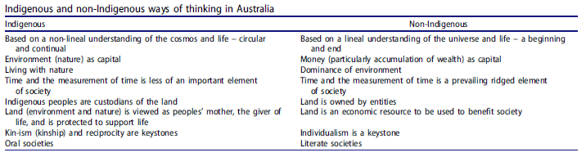

- These cultural differences (counterfactuals) need to be considered when measuring the impact of Indigenous social procurement policies on Indigenous people alongside other more traditional types of counterfactuals such as drop-off, attribution and deadweight.
- Indigenous methodological practices also need to be better respected in undertaking policy evaluations.

What this means
The research presents a new framework of cultural counterfactuals which can be used by policymakers and the construction industry to measure the social impact of Indigenous procurement policies from an Indigenous social perspective.

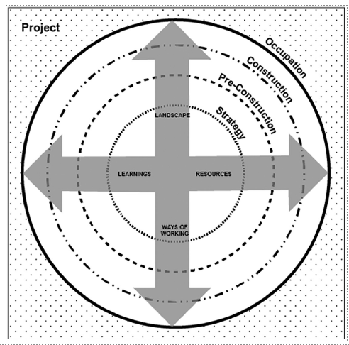

- The framework uses the four Ngaa-bi-nya domains to highlight the areas to be promoted through procurement over the life cycle of a project.
- The Table below gives examples of key questions which stakeholders in each stage of the building procurement life can ask to evaluate Indigenous procurement policies.

