Pathways to meaningful and sustainable employment for people with disability in the Construction industry: a review of the evidence (or the lack of)

This is the tenth fact-sheet about recent international peer-reviewed research relating to social procurement led by the University of Technology (UTS), Sydney, Australia.

This fact sheet summarises a research project (funded by a UTS Social Impact Grant) which undertook a review of international research relating to the employment of people with disability in the construction industry.

The results of this research are currently subject to international peer-review in the draft manuscript listed in the footnote of this factsheet. Depending on the outcome of this process, the results will be published in late 2022 or possibly 2023.

Please feel free to distribute this factsheet to anyone who may be interested.

Professor Martin Loosemore
University of Technology, Sydney
https://profiles.uts.edu.au/Martin.Loosemore

Why the study
- The construction sector has struggled to increase the diversity of its workforce and the industry has a strongly normalised view of an ideal construction industry employee (typically an able-bodies male).
- Barriers to more diverse employment are reinforced by narrow and exclusionary networks from which people are recruited into the construction industry.
- Negative stereotypes associated with perceptions of high costs, low productivity and poor safety linked to those who lie outside the sector’s institutionalised norms (such as people with a disability) are also a major barrier to diversity.
- While diversity research in the field of construction management has focussed on a wide range of excluded groups such as women, Indigenous peoples, culturally and linguistically diverse people and migrants and refugees, research on the employment of people with disability has received relatively little attention.
- Even at a policy level, people with a disability are ignored. For example, the recent Culture in Construction Taskforce’s draft culture standard for the construction industry in Australia, which is meant to address construction industry workforce diversity does not recognise people with disability.
- This lack of research is surprising given that the construction industry in many countries is facing calls to diversify its workforce to address severe skills shortages.
- There is also significant evidence from research in other industries that people with a disability can be highly valuable and productive employees.
- Furthermore, there is significant potential to increase the number of people with disability in the industry’s workforce. For example, in Australia people with disability make up only 8% of the construction workforce, despite representing 15% of the working-age population.
Aim
- The aim of this research was to undertake a review of international academic evidence relating to the inclusion of people with disability in the construction industry.
- The objective of this review was to identify knowledge gaps and clarify concepts to inform future research in this important yet under-researched area, enabling the construction industry to better harness the untapped potential benefits of a more diverse workforce.
What we did
- Following the PRISMA-Scr method a systematic literature review of international research relating to disability employment in construction was undertaken.
- The review was conducted in July 2021 and focused explicitly on peer-reviewed journal articles published in the Scopus data base, ISI Web of Science (WoS), PubMed and Association of Researchers in Construction Management database.
- Peer-reviewed articles ensured a high degree of data integrity.
- The search was limited to literature written in English and was not restricted by date of publication.
- Eligible study designs included qualitative and quantitative methodologies as well as policy discussion.
- After removing duplicates and screening abstracts, we identified 91 articles that discussed disability in the construction sector but only 24 met the inclusion criteria and were included in this analysis.
- These articles were then coded using Gewurtz et al.’s (2016) analytical framework which is based on a scoping review of mainstream disability employment literature outside construction which categorises this research into key seven main themes, which are defined in Table 1.

Table 1. Gewurtz et al.’s (2016) analytical framework

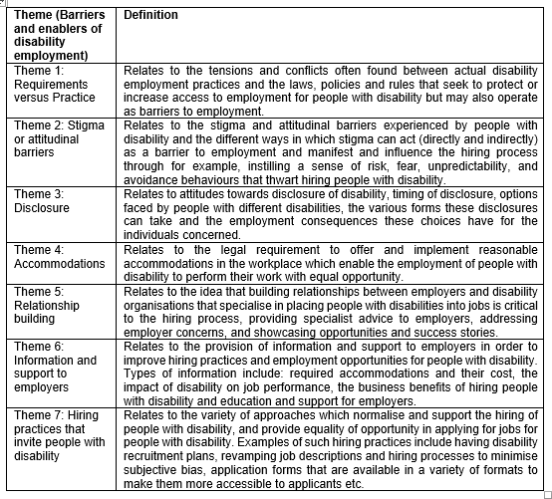

What we found
- Overall, our analysis shows that while there is an established body of construction industry research into workforce diversity, there has been little research on how construction sector culture, organisational structures or other factors such as job design, workforce planning, hiring processes etc. may be exclusionary towards people with a disability.
- There has also been little or no construction research studying hiring strategies and practices deployed for increasing the employment of people with disability in ways that can be made equitable whilst considering career access points, quality of work and career progression from the employee’s perspective.
- While a few construction researchers around the world have explored the employment barriers facing people with disability in construction, there is a clear contrast with the considerable research in other fields investigating strategies to navigate and reduce the barriers experienced by people with disability in gaining employment.
- Another related gap in research which has received relatively little attention in construction is the reporting of the effectiveness of these strategies in achieving improved employment outcomes for people with disability.
- Connections have been made between technological advancement in the construction sector, and an increase in accessibility of construction workplaces and activities to people with disability. However, despite the rhetoric, this opportunity to take advantage of technological and work changes has not yet been fully explored – one example being off-site construction.
- There is evidence within the literature that most employers and agencies do not believe people with disability are suited for many construction professions.
- There is also evidence of ableist practices within the sector that perceive people with disability as a homogenous group rather than a heterogenous group. An example of this is that the work environment for construction workers is often cited as a reason that ‘all’ people with disability are less likely to be considered for work in the sector.
- There is also a gap in construction research regarding disclosure of disability, both from the perspective of people with disability and employers. Studies have identified that employees are reluctant to disclose any form of disability because of stigmas surrounding this and that employers are uncomfortable asking about an applicant’s disability in the employment process making it hard to assess whether the person can do the job.
- Research into the value of social procurement as a mechanism to increase the employment of people with disability in construction in needed given the growing popularity of these policies (although not all mandate the employment of people with disability as part of project contractual requirements).
- Since the goal of social procurement is also to encourage supply chain diversity, the role of minority disability business and social enterprises merits particular attention in increasing employment of people with disability indirectly within the industry.
What this means
- This scoping review showed that there is a lack of research evidence underpinning strategies to increase the employment of people with disability in the construction industry, compared to other industries.
- The overall conclusion is that construction research needs to balance its current emphasis on barriers (seeing people with disability as a risk) with equivalent research on solutions (seeing people with disability as an opportunity).
- It is clear from our review that despite the implementation of numerous ‘formal’ laws and regulations relating to inclusive employment for people with disability, there are numerous under-researched ‘informal’ and unwritten industry norms and practices which can potentially undermine the intent of these policies.
- We also reflect on the additional responsibility of the construction sector to engage with inclusive employment strategies given the high level of disabling injuries caused by the sector.
- The scoping review also identifies a methodological gap in the research reviewed by highlighting the need for more construction research designs to include people with disability as prioritised research participants as well as research investigators.
- The lack of longitudinal research including success stories in construction employment and long-term employment outcomes in the construction industry are also gaps for future construction researchers to address.
- If the construction industry hopes to employ more people with disability, it is critical that research investigates the perspectives of people with disability currently employed in the sector, as well as job-seekers and school-leavers. Understanding the how people with disability perceive the sector from the inside will help build successful recruitment strategies for people from the outside and vice versa.

