Barriers to social procurement in the construction industry: a subcontractor’s perspective

This is the first in a series of regular fact-sheets about recent international peer-reviewed social procurement research led by the University of Technology, Sydney, Australia.

This fact sheet summarises a research project which explored the barriers to the implementation of social procurement policies from the perspective of subcontractors working in the Australian construction industry.

The detailed results of this research are published in the internationally peer-reviewed article listed in the footnote of this factsheet.

Please feel free to distribute this factsheet to anyone who may be interested.

Professor Martin Loosemore
University of Technology, Sydney
https://profiles.uts.edu.au/Martin.Loosemore

Why the study
- Social procurement is an increasingly popular way for governments to leverage their construction and infrastructure spending to address disadvantage in the community.
- Social procurement policies require construction supply chains to create employment and training opportunities for people suffering disadvantage in the communities in which they build.
- It is subcontractors that will ultimately bear the main responsibility for delivering on these new contractual requirements, as social procurement risks are passed down the contractual chain by principal contractors.
- However, the subcontractor’s voice is largely absent from the social procurement debate, despite employing the majority of people in the construction industry.

What we did
- A survey of 70 Australian subcontractors was undertaken to explore perceived barriers to integrating six groups targeted by social procurement policies into the construction workforce.
- These groups included: migrants and refugees, disengaged youth, people with a disability, ex-offenders, women and Indigenous workers.
What we found
- Subcontractors perceive significant safety, productivity and cost risks in employing people from these groups. These perceptions do not align with reality in many cases.
- Disengaged youth are perceived as the highest risk group, followed by migrants and refugees, people with a disability, ex-offenders, women and Indigenous workers.
- Employment priorities reflect these perceptions and the order of priority for hiring from disadvantaged groups was: Indigenous, Women, Migrants & Refugees, Disengaged Youth, people with a disability and Ex-Offenders.
- Employment priorities also reflect government policy targets and government support made available to recruit for each group.
- The perceived barriers faced by each group vary significantly as indicated in the table below

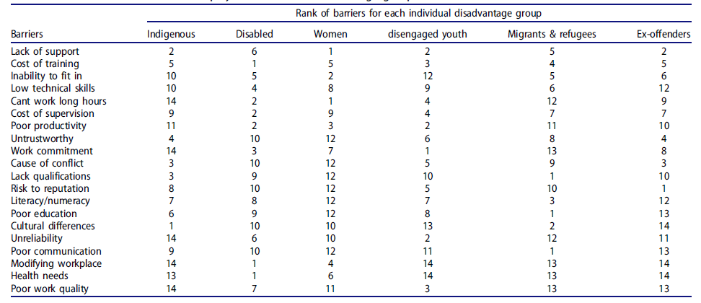

- A lack of government support ranked as the highest barrier across all cohorts.
- Social procurement is poorly understood and is seen as yet another compliance burden. Few benefits are seen by subcontractors.
- Younger firms and smaller firms are less likely to hire women and Indigenous people and hiring priorities appear to be guided by compliance and convenience rather than any strategic interest in the potential benefits claimed around social procurement such as workforce diversification.
- The results suggest that most firms are driven by compliance rather than optimising social procurement outcomes for job seekers.

What this means
- Social procurement policies could ironically further disadvantage already vulnerable people if they are imposed onto an unprepared and unwilling construction industry without regard to the industry’s culture, organisational characteristics and capacity to deliver.
- The sector responds strongly to government mandated policies which set clear targets and make social procurement a source of competitive advantage.
- The construction sector is unlikely to engage with social procurement if these policies are removed.
- Social procurement policies must be strongly implemented, monitored and enforced if they are to be effective in construction and infrastructure projects.
- Governments may need to rethink the support they offer to help industry implement these policies – especially for Migrants & Refugees, Disengaged Youth, people with a disability and Ex-Offenders.
- It is critically important to consult with industries like construction to understand supply and demand constraints. Barriers to implementation are likely to be industry-specific.
- Our results indicate that targeted legislation with specific deliverables supported by policies which provide support and remove barriers to employment for each group could be a powerful way for social procurement policy-makers to encourage the employment of disadvantaged groups in the construction supply chain.
- If the barriers exposed in this research are not addressed, then there is a real danger that social procurement policy will run ahead of practice and that the ambitious targets being set will not be met.
- In construction industry supply chain capacity to comply with these policies, governments should focus on three main areas of support: monetary assistance to cover extra costs of employment (where there is evidence to support extra costs are incurred); training employers to change attitudes, highlight opportunities from social procurement and reduce negative stereotypes about targeted groups; and training for different cohort groups to help them fit into the industry.

